**Operators and Assignments**

1) Increment and decrement operator

2) Arithmetic operators

3) String concatenation operator

4) Relational operators

5) Equality operator

6) Instanceof operator

7) Bitwise operators

8) Short circuit operators

9) Type cast operator

10) Assignment operator

11) Conditional operator

12) new operator

13) [] operator

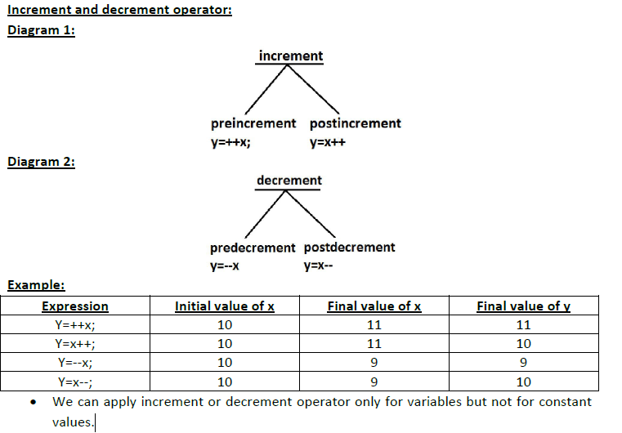

**2) Arithmetic operators: (+,-,*, /, %)**

**3) String concatenation operator:**

->The only operator which is overloaded in java is “+” operator. Sometime it acts as

arithmetic addition operator and some time concatenation operator.

-> If at least one argument is string type then “+” operator acts as concatenation and if

both arguments are number type then it acts as arithmetic addition operator.

Example 1:

String a="bhaskar";

int b=10,c=20,d=30;

System.out.println(a+b+c+d);//bhaskar102030

System.out.println(b+c+d+a);//60bhaskar

System.out.println(b+c+a+d);//30bhaskar30

System.out.println(b+a+c+d);//10bhaskar2030

**4)Relational operator: (<, <=, >, >=)**

->We can apply relational operators for every primitive type except boolean.

**5)** 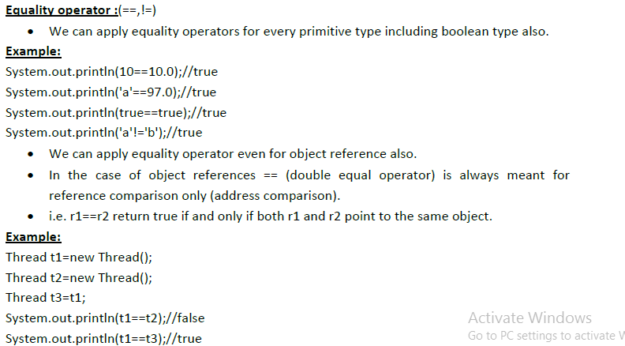

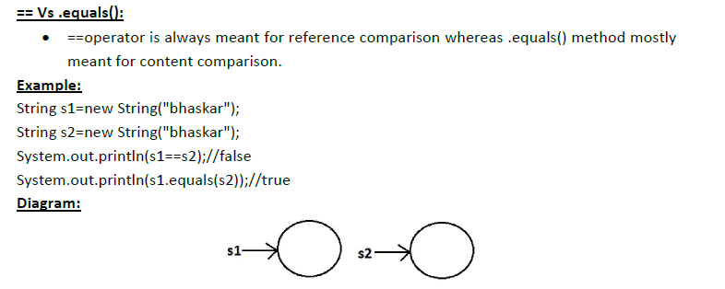

**6)**

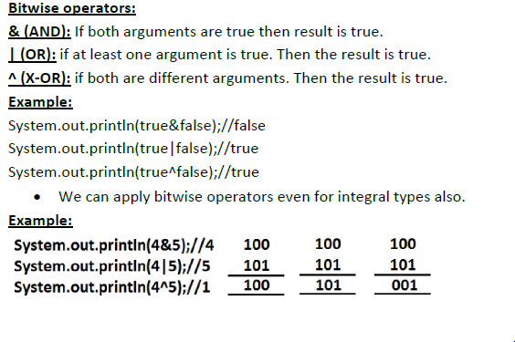

**7)**

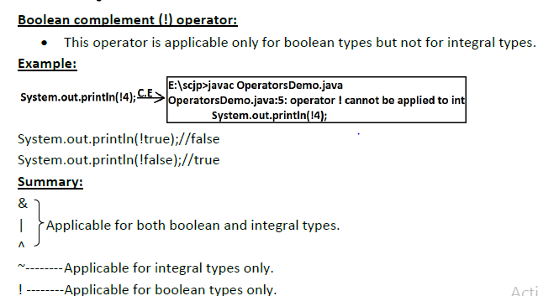

**8)**

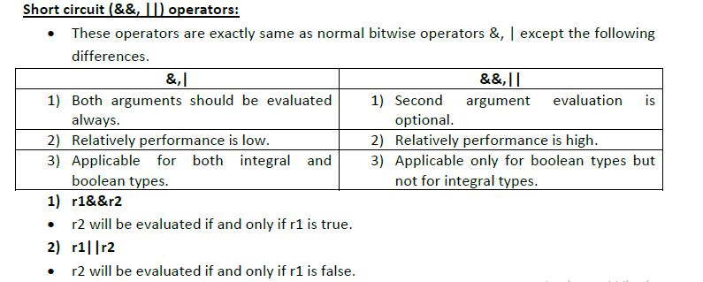

9)



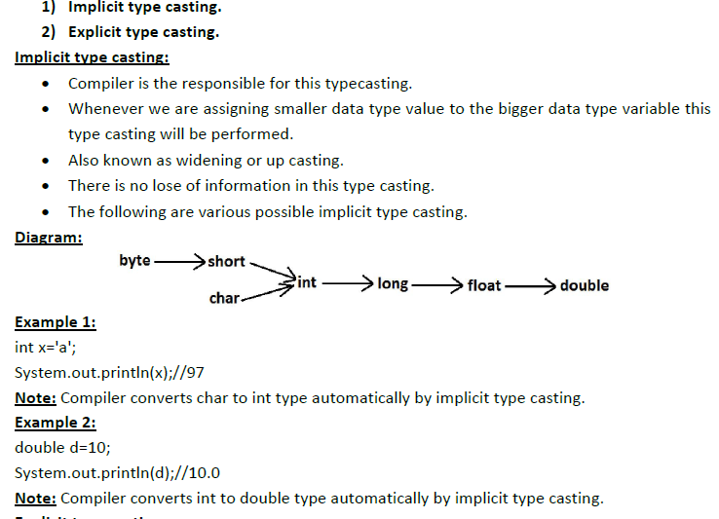

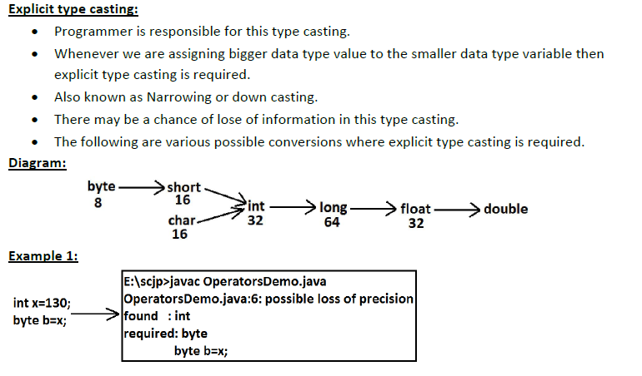

10)Assignment operator

11) 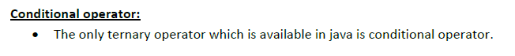

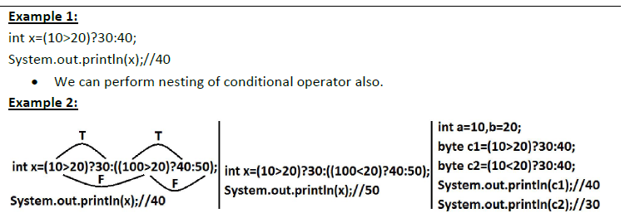

12)

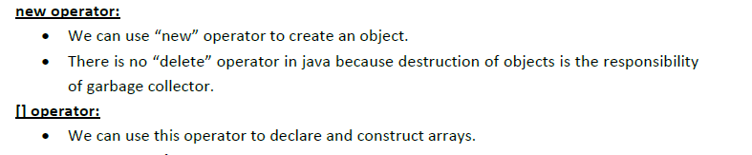

**Flow Control**

